OxyCost Feedback:
For Mohit:
- Avoid terms like “decide” and “recommendation” – Clearly mention in the footer that this is not a recommendation.
- Throughout the tool, let’s give the user the option to override calculations and logic (wherever possible). The user feeds in a scenario -> The tool outputs a value. The accuracy of the output will depend on the inputs entered by the user (including all the underlying assumptions that they have an option to override).
- States might not be okay with broadcasting their default values for many parameters -> consider the upside vs potential downside of mentioning each value
- Can we also provide an option to toggle between different units (Ref: “compare the per-cu-m cost of each oxygen source”)
- Some of these are not standard terms or very intuitive (Ref: “oxygen-bed band”, “median profile”, “Cost Character”, “real peer facilities”, “frozen scenarios” etc.)
- The color-coding scheme for input cells could be reviewed. I would suggest using green to indicate user-entered values, yellow for default values or assumptions, and red to highlight missing inputs or values that require user entry.
- Some language might require modification if there are separate links / versions created for our program states
  - “data from three states” -> “data from your state”

For the LLM:
Make the following improvements:
Overall:
- Adapt the overall language to be easily understood by India based healthcare staff at government hospital facilities (avoid terms like: “Fixed costs are sunk” that the audience of the tool will find difficult to understand)
In Tab 1: “How to use this model”
- Under the heading “What this tool is”:
  - Avoid terms like “decide” and “recommendation” - This tool is meant to help the users understand their oxygen costs so that they can make more informed decisions. With the terminologies used, please make sure that the tool should not recommend anything, only provide information to help the users make a data driven decision.
  - In the part that says “Defaults are drawn from a WJCF facility-level assessment of 92 facilities across Madhya Pradesh, Chhattisgarh and Punjab.”, clearly mention that these defaults are provided to reduce the effort in filling the data. The tool makes it easy for the user to view each of these default values and the underlying assumptions behind all calculations, and in most cases allows them to override these values. Wherever real values are known, the user is encouraged to override the default values to arrive at a more accurate estimation.
  - Also, avoid mentioning the names of the three states in the summary, just mention “three states in India”.
- Under the heading “Two tools in one”:
  - Avoid using the term “get a recommendation”. Replace it with something on the lines of “use the insights to determine the most cost-effective oxygen source for your facility”
- Under the heading “The four oxygen sources”:
  - From “Cost Character” column of LMO, remove: “; rent dilutes with use”
- Under the heading “How the screen is organised”:
  - “Salary is deliberately left out — pay is sensitive, so it is never benchmarked.” – There is no need to call this out explicitly: Remove!

In Tab 2: “Facility calculator”
Inputs
“what you can change” -> “information to be filled by the user”

Step 1: Estimate monthly demand
(These terms appear throughout the tool across multiple sections. Can be changed everywhere)
“Required — you must enter” -> "Required field — enter a value"
“Optional — preset you may change” -> "Pre-filled defaults — update with actual values if known" (These fields are not optional. A better way to frame it would be that these values are initially set as default values, but should be replaced by actual values by the user if known

Step 2: How many of each source?
“Each unit gets its own input panel in Step 3” -> Details corresponding to each source can be added in Step 3”
Definitions of sources below the source names can be excluded (“On-site generation from ambient air”, “Bulk cryogenic, tanker-delivered”, “Bedside, low-purity supplement”, “Portable, supplier-refilled” etc. – This tool will be used by a technical audience who are familiar with these sources)
“Concentrator groups” -> “Oxygen concentrators”
“Cylinder lines” -> “Oxygen cylinders”
For OCs and cylinders, the count next to the “i” icon should read “1 capacity type”, “2 capacity types” etc. instead of “1 unit”, “2 units”…)

Step 3: Source details
“open each unit and…” -> “click on each source type below and…”
“the entered units cover” -> “the entered sources cover”
“All costs are GST-inclusive” -> “Please enter all costs inclusive of GST”
“No source output yet — fill in Step 3” -> “No source output yet — complete the fields below” (this instruction is provided in Step 3 itself)
“All fields here are optional presets” -> “These fields are pre-populated with default values. Verify and update them before proceeding” (Since the values are not optional, avoid using the word "optional." The message should communicate that these are default/pre-filled values that the user is expected to verify and update)
For “Oxygen technician / HR salary”: set default value as INR 10,000 instead of 13000
“MGPS AMC (annual)” -> “MGPS AMC (annual, if applicable)”
“MGPS maintenance (annual)” -> “MGPS ad hoc maintenance & repairs (annual)”
Definitions of sources alongside the source names can be excluded (“on-site generation”, “bulk cryogenic supply”, “portable, supplier-refilled”, “supplementary only” etc. – This tool will be used by a technical audience who are familiar with these sources)

PSA plants
(“i” symbol alongside GST-inclusive) “All costs shown are inclusive of GST. LMO rental & handling apply 18% GST and refilling 12%; PSA, cylinder and concentrator prices are taken as GST-inclusive — adjust the preset if your quotation is pre-GST.” -> “Default costs are pre-filled inclusive of GST. Review and update them to match your quotation (e.g., if your quotation is pre-GST).”
“60.00 cu m/hr · 60.00 Nm³/hr” -> “60 cu m/hr · 60 Nm³/hr” (these capacities are typically mentioned without decimals)

In the “i” expansion, we mention 40-80KW as typical for 1000LPM plant, but when I enter that value, it mentions that it’s lower than 97% of peers. I think we can remove the Peer description below the cell and the corresponding pop up
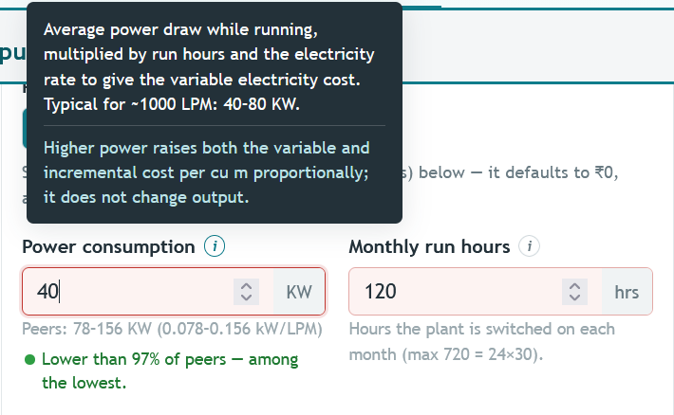

“Average power draw while running, multiplied by run hours and the electricity rate to give the variable electricity cost. Typical for ~1000 LPM: 40–80 kW.
Higher power raises both the variable and incremental cost per cu m proportionally; it does not change output.” -> “Total rated power of all PSA plant components (e.g., air compressor, oxygen generator, dryers, and auxiliary equipment). This value is used to estimate electricity consumption based on operating hours. Typical for a ~1000 LPM PSA plant: 40–80 kW.”

LMO
“Litre LMO” can also be added as an option and set as default value instead of “cu m gas” – For LMOs, it is more widely used than the units that are currently available on the drop down

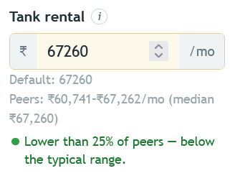
Doesn’t look consistent – Median value cannot be lower than 25% of peers

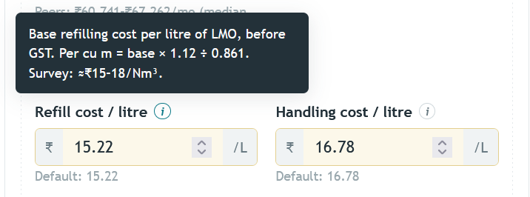
The instructions in the beginning say that all amounts should be entered inclusive of GST, but here it says that a GST calculation will be done on top of these values. Need to ensure that the two instructions are in alignment with each other

Outputs
“ (all-in, per cu m)” -> “ (per cu m)”

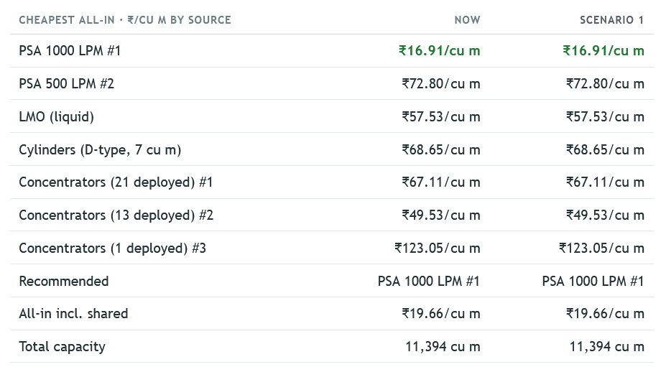
The “All in” terminology is confusing at places. For example: What does it mean here?

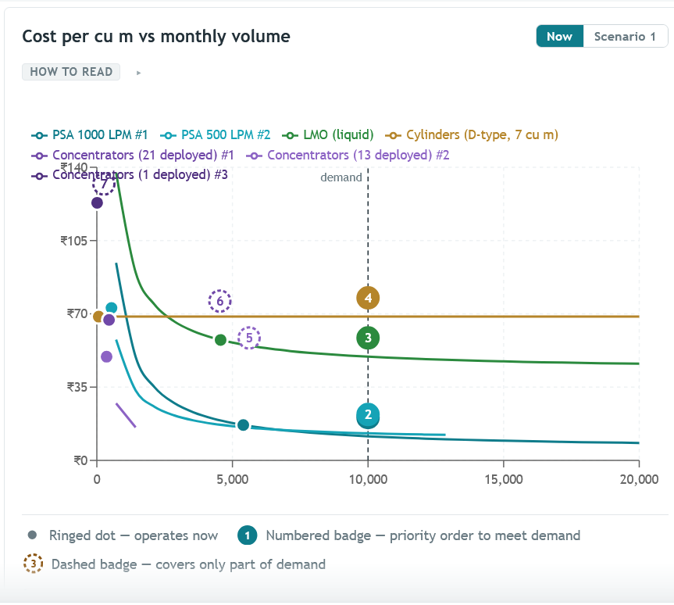
This chart isn’t rendering properly

In Tab 3: “District / state planner”

In Tab 4: “Methodology”

